
Date :
|
Your Full Name: Age:
Address:

Country of Origin:
Phone Number:
E-mail Address:
Height (cm) Weight (kgs)
Are you a returning customer?

Measuring Instructions
I will use Centimetres
I will use Inches

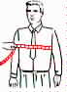  Chest  Measure around body well up under arm holes. | 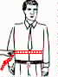  Stomach  Measure around  stomach line. | 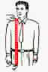  Length  Measure from  lower collar seam to length desired. | 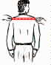  Full Shoulder  Measure back at end of shoulders.
Size: | Size: | Size: | Size:
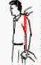  Sleeves  Measure sleeves from  shoulder seem to length desired | 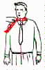  Neck  Measure around  the Neck. | 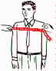  Front  Measure from one armhole to  other arm hole in front. | 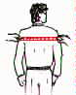  Back  Measure from one armpit to other arm pit at Back.
Size: | Size: | Size: | Size:
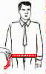  Waist  Measure around  waist Line. | 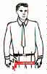  Hips  Measure around  hips at widest  point of seat  but not tight. | 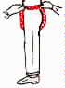  Crotch  Measure from  center front waist  under legs to  center back waist. | 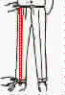  Length  Measure from  top of waist  band to bottom  of cuff.
Size: | Size: | Size: | Size:
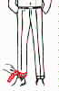  Cuff  Measure width around  cuff as shown. | 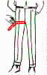  Thigh  Measure width around  the thigh as shown. | KNEES  Measure around your knees. | WRIST  Measure around your wrist.
Size: | Size: | Size: | Size:
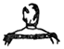 | 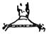 | 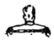 | << Select the pictures  nearest to your figure >> | 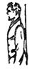 | 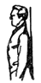 | 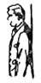 | 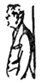 | 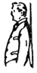
Normal Shoulders Normal Neck | Sloping Shoulders Long Neck | Square Shoulders Short Neck | << Select the pictures  nearest to your figure >> | Normal Posture | Erect | Forward Stoop | Forward Stomach | Stout

You have taken the sizes:
Very exact
Comfortable
Very Loosely
You like your clothes very:
Snug
Comfortable
Loosely comfortable
Very loose
Very baggy

How do you wear trouser ?
At waistline
High at belly
Lower - under belly

